Experiment 11
a)Simulate Static Routing Configuration using CISCO Packet Tracer
AIM: To simulate Static Routing Configuration using CISCO Packet Tracer
Procedure: Static Routing Configuration Using Cisco Packet Tracer
- Open Cisco Packet Tracer and place two routers, two switches, and two PCs.
- Connect the PCs to the switches and the switches to the routers using suitable cables.
- Assign IP addresses and subnet masks to the PCs and router interfaces.
- Enable router interfaces using the no shutdown command.
- Configure static routes on each router using the following command:
ip route destination_network subnet_mask next_hop_IP
- Verify the routing table using show ip route.
- Test connectivity between the PCs using the ping command.
- Observe packet transmission in Simulation Mode to confirm successful communication.
Output:

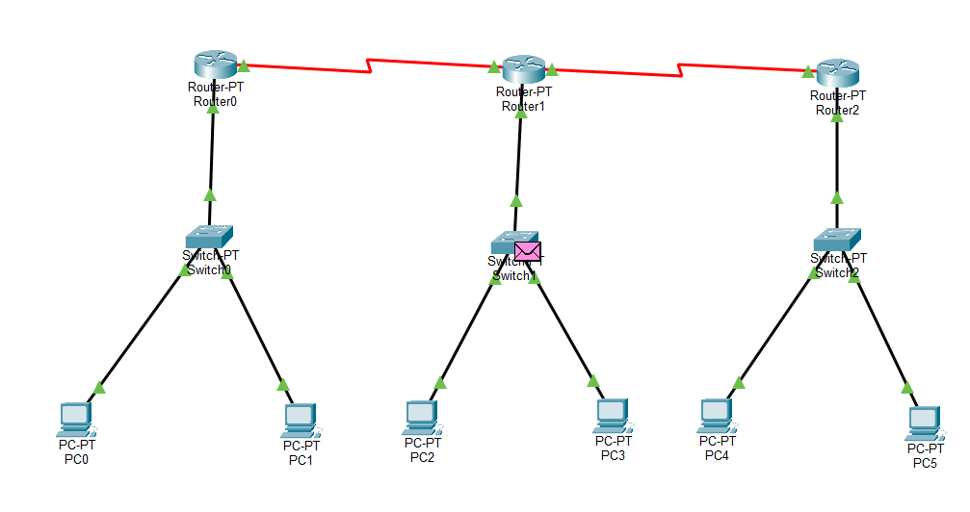
Click on for every configurations that u make
Router 0 Config
FastEthernet 0/0 : 10.10.10.0
Serial2/0 : 40.40.40.1
PC0
IPV4 Address: 10.10.10.1
Default Gateway: 10.10.10.0
PC1
IPV4 Address: 10.10.10.2
Default Gateway: 10.10.10.0
Router 1 Config
FastEthernet0/0:
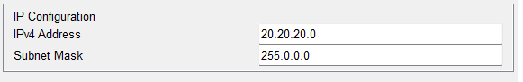
Serial2/0:
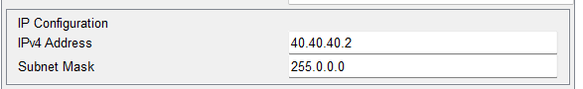
Serial3/0:
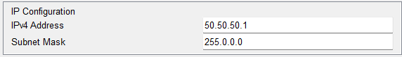
PC2
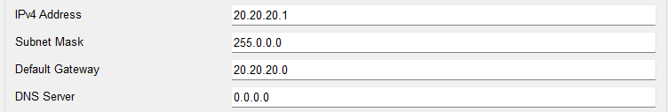

PC3
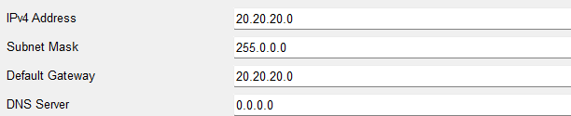

Router 2 Config
FastEthernet0/0:
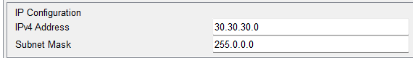
Serial2/0:
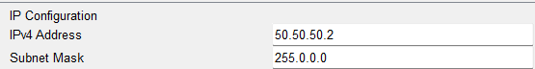
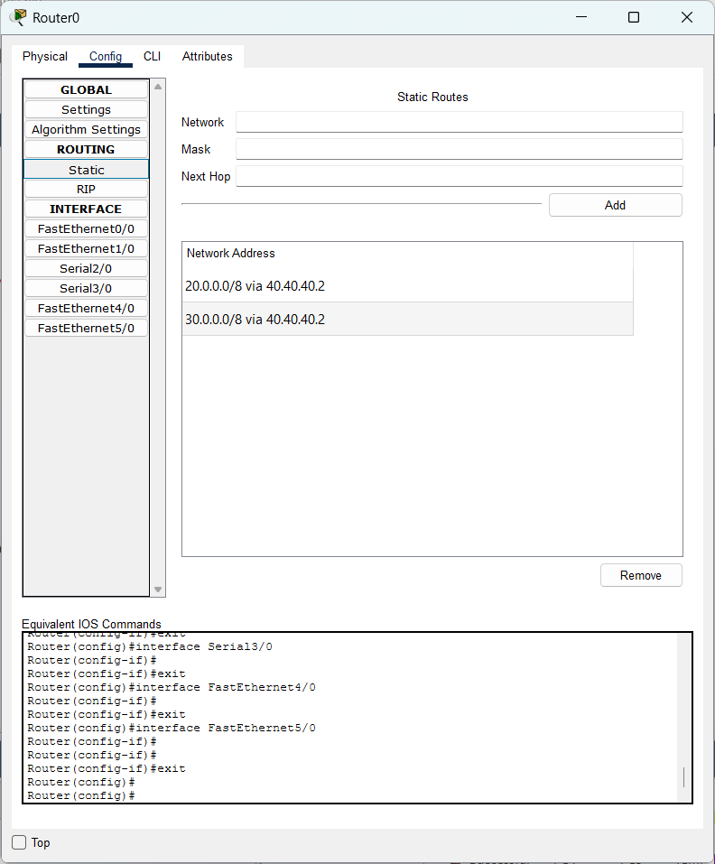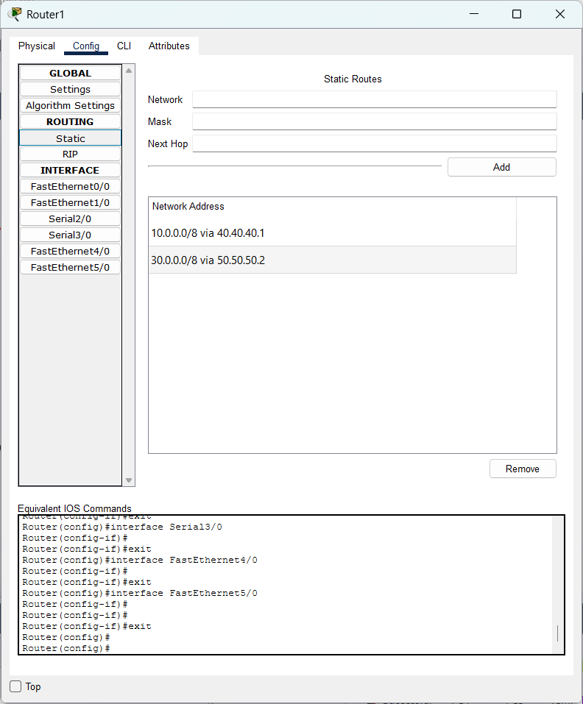
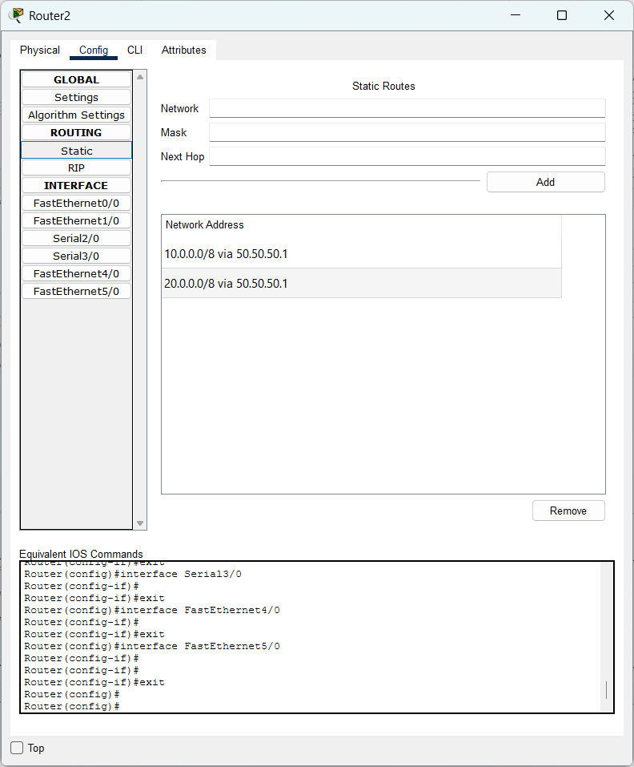

(b)Simulate RIP using CISCO Packet Tracer
AIM: To Simulate RIP using CISCO Packet Tracer
Procedure:
- Open Cisco Packet Tracer and place two routers, two switches, and PCs in the workspace.
- Connect the PCs to the switches and the switches to the routers using suitable cables.
- Assign IP addresses and subnet masks to all PCs.
- Configure IP addresses on the router interfaces using the CLI.
- Enable the router interfaces using the no shutdown command.
- Configure routing between the networks using static routes or a suitable routing protocol.
- Verify connectivity by using the ping command between PCs in different networks.
- Observe packet transmission in Simulation Mode and verify successful internetwork communication.
Output:
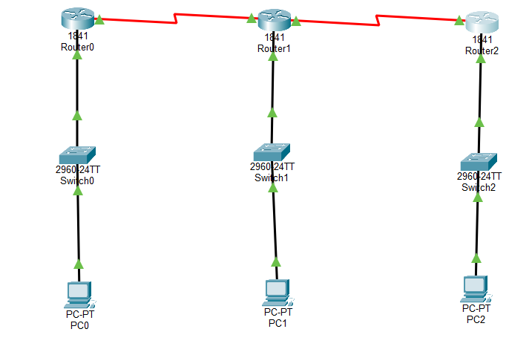
Router 0 Config
FastEthernet 0/0:
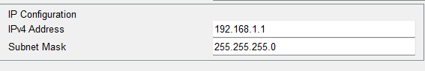
Serial 0/0:
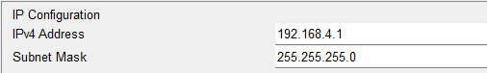
Router 1 Config
FastEthernet 0/0:
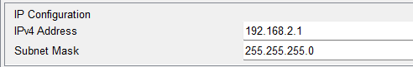
Serial 0/0:
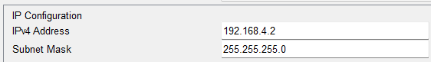
Serial 0/1:
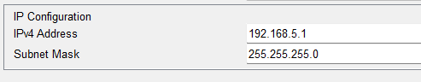
Router 2 Config
FastEthernet 0/0:
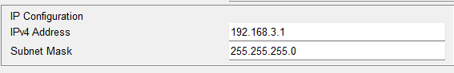
Serial 0/0:
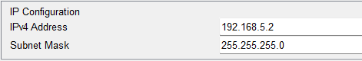
Router 0 CLI
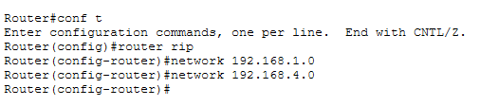
Router 1 CLI
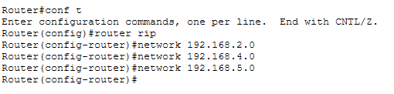
Router 2 CLI
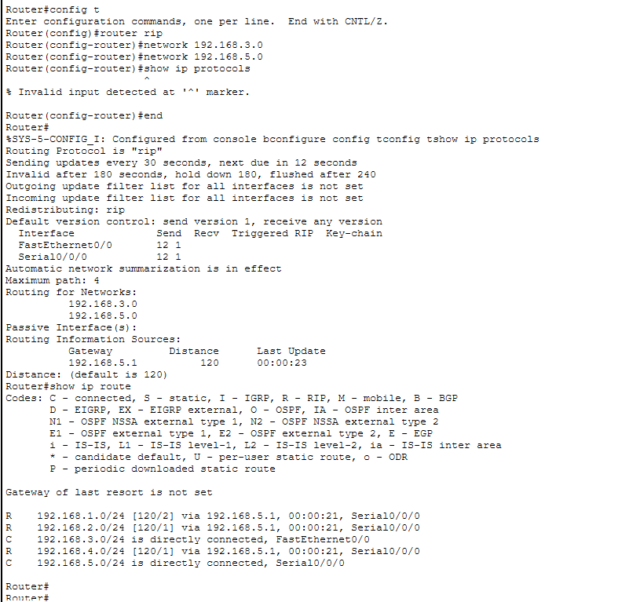
From PC0
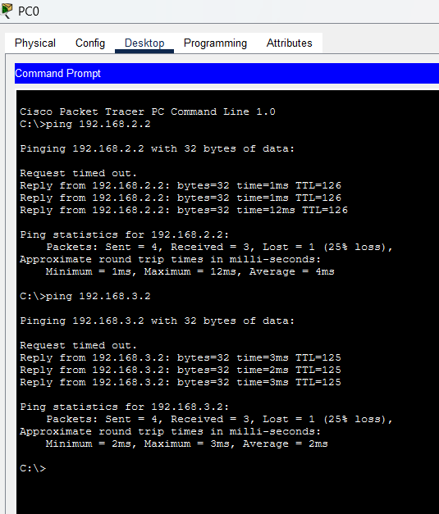
From PC1
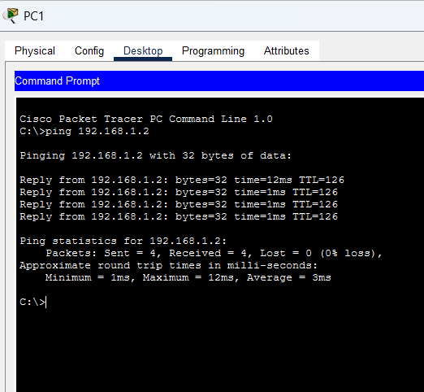
From PC2:


